Quiz 2 : Digital Logic Design 750231 07/04/2015
Name : Student #:
Choose the correct answers in the following questions:
- What is the output X if both inputs A and B are 0?
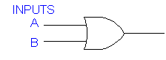X
  - 0
  - 1
  - A '
  - B '

- For a three inputs (A,B C) OR gate, what inputs are needed if output=0?
  - A=0, B=0, C=1
  - A=0, B=1, C=0
  - A=0, B=0,C=0
  - A=1, B=1, C=1

- What is the output X if input A=1, B=0 and C=1?
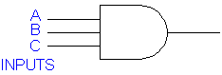
  - 0
  - 1
  - A
  - C

- Half adder circuit is ______.
a. Half of an AND gate
b. A circuit to add two bits together
c. Half of a NAND gate
d. none of above

- Half adder consists of. …… and …..Gates
a. EX-OR, AND
b. EX-OR, OR
c. EX-OR, NOT
d. None of the above

